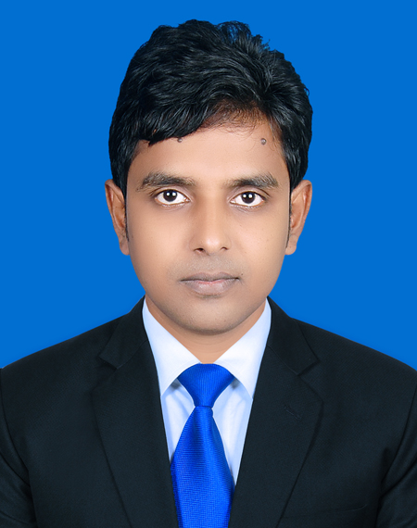
RESUME
OF
MD.Imran Hasan
Mobile: +8801515261160/01710181786
E-mail:imranhasan2006@gmail.com

Career Objective
To work in a dynamic, intensive environment, where the creativity and interest can be found to develop the skills as well as the career with a strong emphasis on sustained growth and development.

Academic Records

- B.Sc in Engineering :-
- Degree : B.Sc in Electrical & Electronics Engineering.
- University : Green University of Bangladesh (GUB).
- Subject : Electrical & Electronics Engineering.
- Passing Year : 2022
- CGPA : 3.60 (out of 4.00)

- Diploma in Engineering :-
- Degree : Diploma in Power Engineering.
- Institute Name : Dinajpur Polytechnic Institute.
- Board : Bangladesh Technical Education Board (BTEB), Dhaka.
- Technology : Power Technology.
- Passing Year : 2012
- CGPA : 3.37 (out of 4.00)

- Secondary School Certificate:-
- Degree : S.S.C
- School Name : Muradpur High School.
- Board : Bangladesh Technical Education Board (BTEB), Dhaka.
- Group : Building Maintenance.
- Passing Year : 2008
- GPA : 4.36 (out of 5.00)

Industrial Attachment

- I did my “Industrial Attachment Three months in Proton Service Center.

Computer Literacy

- Package Program : Microsoft Office Word
- Others : E-mail and Internet Browsing

Working Experience (1)
Area of Experience: Mechanical and Electrical Maintenance.
Company Name : Unilon Textiles Ltd.
Designation : Assistant Engineer (Mechanical & Electrical)
Service Length : 18.12.2021 to till now.

Working Experience (2)

Area of Experience: Mechanical and Electrical Maintenance.
Company Name : Opex & Sinha Textile Group.
Designation : Assistant Engineer (Mechanical & Electrical)
Service Length : 01.02.2016 to to 07.12.2021

Working Experience (3)
Area of Experience: Mechanical and Electrical Maintenance.
Company Name : Opex & Sinha Textile Group.
Designation : Sub-Assistant Engineer (Mechanical & Electrical)
Service Length : 11.05.2013 to 01.31.2016.

Working Experience (4)

Area of Experience : Mechanical and Electrical Maintenance.
Company Name : Ahsan Composite Ltd.
Position held : Sub-Assistant Engineer (Mechanical& Electrical)
Service Length : 01.11.2012 to 08.05.2013.

Major Responsibilities:-
        - Knit Dyeing & Finishing Maintenance of Production Machinery Such as ……
        - Motor controlling such as(Direct Online starter, Star-Delta starter, Motor reversed and Forward)Motor fault check, MDM and SDB Board Trobule shooting, Inverter parameter setting, load line calculation, House wiring.
        - Pipe line Installation. Steam line & water line servicing, all types of motor bearing change, Centrifugal pump mechanical Seal Change, All type of valve change etc.

Types of Machineries
        - A.K Machine Capacity 800 & 600 kg.
        - Fongs Machine 2000 Hongkong Capacity 1000, 600, 300 & 50 kg.
        - Stenter Machine Moenus Krantz K30 Germany.
        - Techninox Machine Portugal Capacity 1000 & 1200 Kg.
        - Open Compacting Machine, Ferraro Italy.
        - Tubetex Padder & Compactor Machine Tube Tex USA.
        - Wet Silting Machine, EL Italy & Dry Silting Machine Fongs, Hongkong.
        - Dryer Machine Obermier, Austria.
        - Hydro Extractor Machine.
        - Sueding Machine Italy.

Others Responsibilities

        - Factory power plant system monitoring.
        - Boiler, Compressor, Generator, General Operation & Trouble Shooting and Servicing.
        - Steam line Insulation.
        - Different type Pump & Motors Repair and Maintenance.

Language Proficiency

- English : Fair reading, writing and speaking ability
- Bengali : Mother tongue.

Personal Details

- Name : Md. Imran Hasan.
- Father’s Name : Md. Mojibor Rahman
- Mother’s Name : Mrs. Akhtara Banu.
- Date of Birth : 01-01-1993
- Gender : Male
- Marital Status : Married
- Religion : Islam
- Blood Group : O(+)
- Nationality : Bangladeshi
- National ID No : 2839968704
- Permanent Address: Village:-Nunaich, Post:-Godagari, Thana:-Kotowali, Dist:-Dinajpur.
- Current Location : Madhabdi, Narshingdi.
- Contact No. : 01515261160/01710181786

References

- Name : Md. Moniruzzaman (Monir).
- Designation : Manager (Maintenance).
- Department : Maintenance
- Organization : Unilon Textiles Ltd.
- Contact No. : 01716547308.

I undersigned, hereby declare that I will be responsible for any wrong information provided here.

……………………
Date: …………….. Md. Imran Hasan

